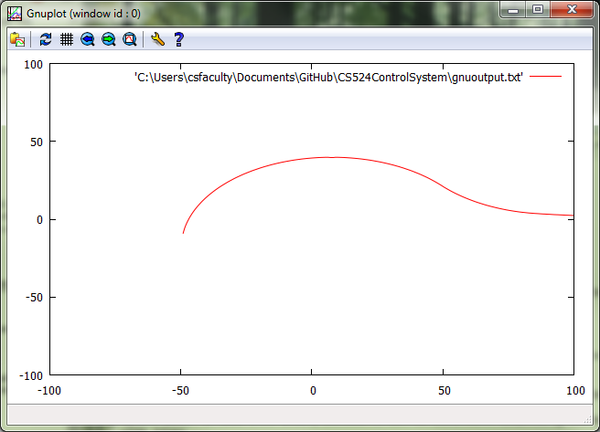

-49, -9, 1, 10, true

Iteration Count: 5000

Distance: 4915.526083877559

Area: 5920.023439570317

Average: 1.290810762210919

Standard Deviation: 4.740183354328174

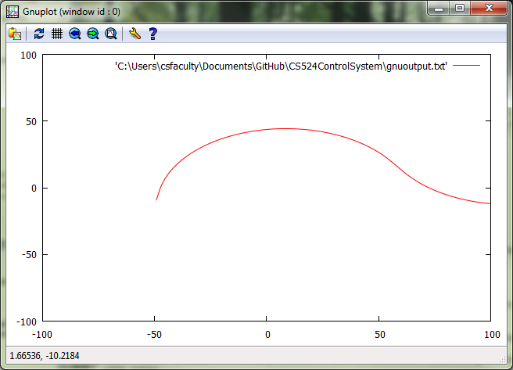

-49, -9, 1, 10, false

Iteration Count: 5000

Distance: 4882.3703002119155

Area: 7474.9205514717005

Average: 1.6494056336928884

Standard Deviation: 5.484632118200104

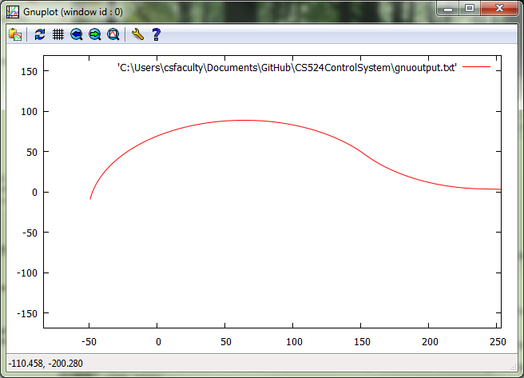

-49, -9, 2, 10, true

Iteration Count: 5000

Distance: 9874.675782941269

Area: 27056.949185987927

Average: 2.9748391751938015

Standard Deviation: 10.813559506015444

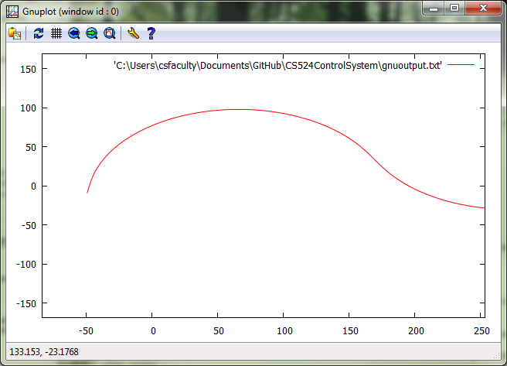

-49, -9, 2, 10, false

Iteration Count: 5000

Distance: 9803.23932514688

Area: 33339.42192110585

Average: 3.719585976453613

Standard Deviation: 12.442638899809856

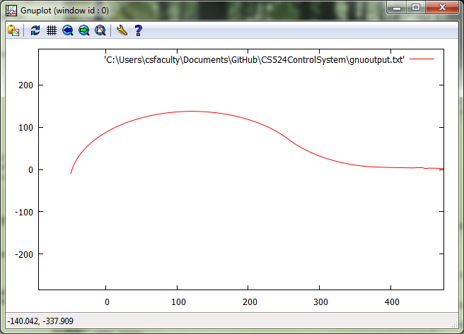

-49, -9, 3, 10, true

Iteration Count: 5000

Distance: 14834.25455892547

Area: 63767.955675374855

Average: 4.687511665606047

Standard Deviation: 16.907004191646276

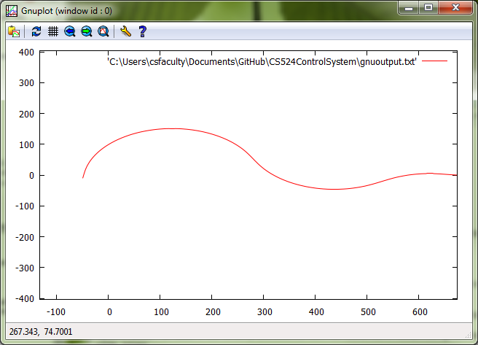

-49, -9, 3, 10, false

Iteration Count: 5000

Distance: 14726.201275450832

Area: 77234.88087713475

Average: 5.769368342882875

Standard Deviation: 19.38240653974751

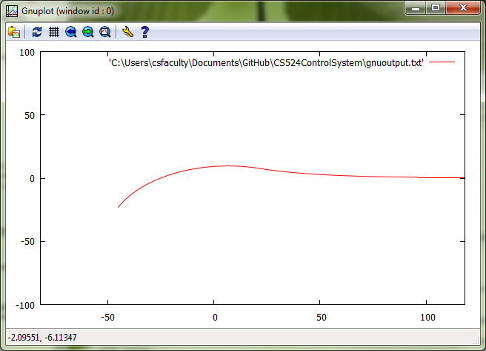

-45, -23, 1, 27, true

Iteration Count: 5000

Distance: 4941.17041109394

Area: 882.2776750728829

Average: 0.21040597541235365

Standard Deviation: 1.3136154856684108

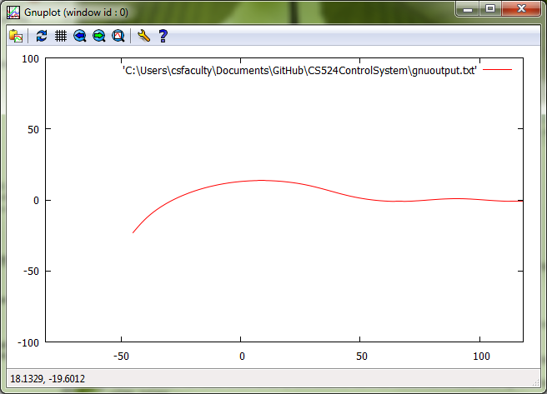

-45, -23, 1, 27, false

Iteration Count: 5000

Distance: 4919.423862359193

Area: 3686.466442090487

Average: 0.778794589899358

Standard Deviation: 1.5520086141488287

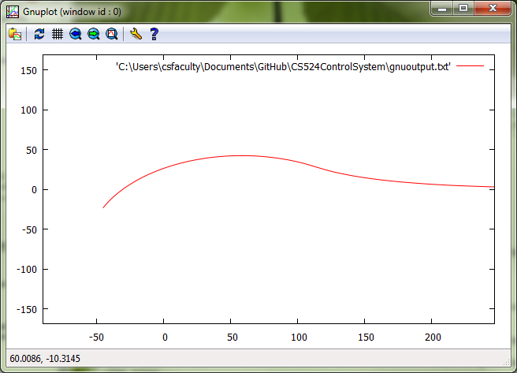

-45, -23, 2, 27, true

Iteration Count: 5000

Distance: 9922.908905921733

Area: 10360.677999329111

Average: 1.091284055677114

Standard Deviation: 4.422627702864755

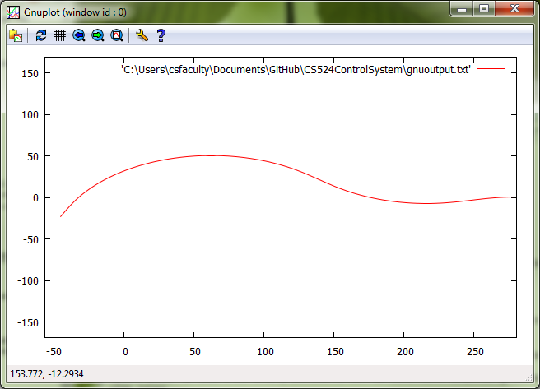

-45, -23, 2, 27, false

Iteration Count: 5000

Distance: 9874.962399579534

Area: 18723.97678571881

Average: 1.9587659234097725

Standard Deviation: 5.329917709989559

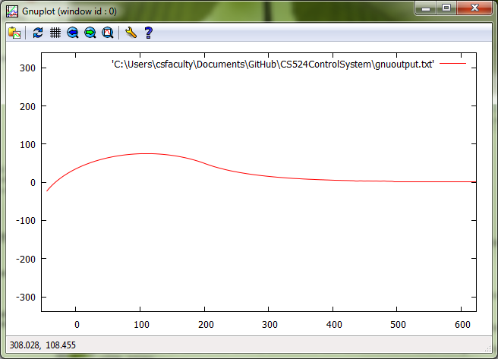

-45, -23, 3, 27, true

Iteration Count: 5000

Distance: 14903.833882425442

Area: 29349.54217178716

Average: 2.05486683403247

Standard Deviation: 8.053152715154628

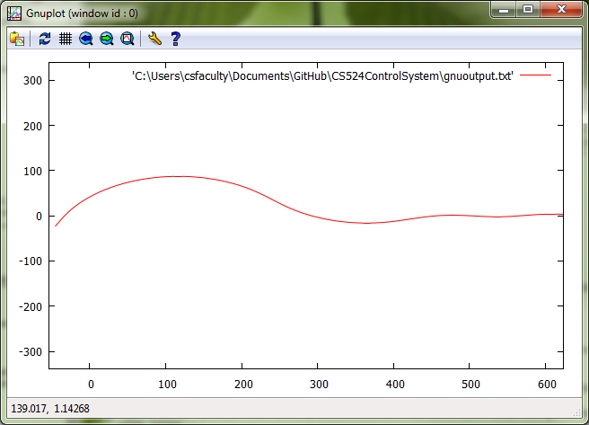

-45, -23, 3, 27, false

Iteration Count: 5000

Distance: 14827.75012820813

Area: 46625.93198943915

Average: 3.267588559244499

Standard Deviation: 9.531894979335833

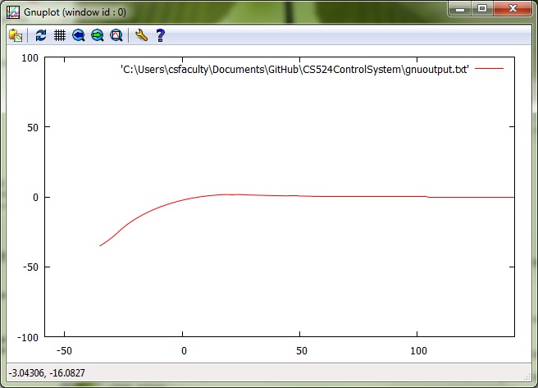

-35, -35, 1, 45, true

Iteration Count: 5000

Distance: 4950.410132025931

Area: 1090.8631986865587

Average: 0.2803733834342151

Standard Deviation: 1.9496175919872412

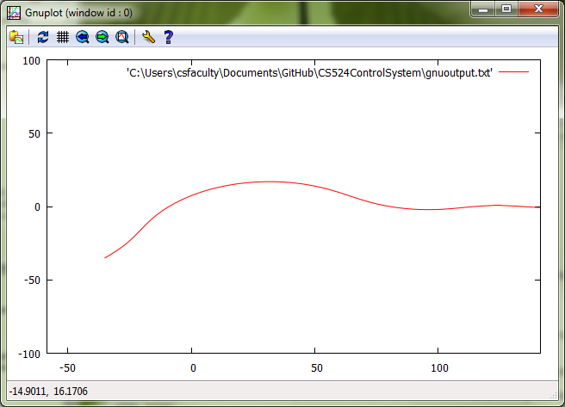

-35, -35, 1, 45, false

Iteration Count: 5000

Distance: 4919.854378688409

Area: 4439.594974262085

Average: 0.9681778319268547

Standard Deviation: 2.4710855454530973

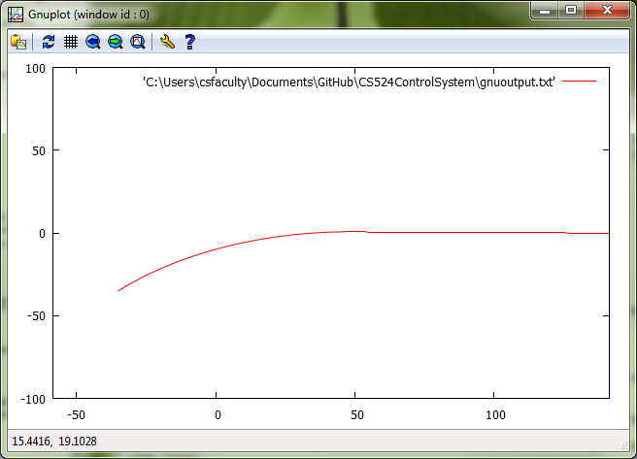

-35, -35, 2, 45, true

Iteration Count: 5000

Distance: 9954.368316879976

Area: 1527.2496865606763

Average: 0.1798215391795663

Standard Deviation: 1.5461939545940986

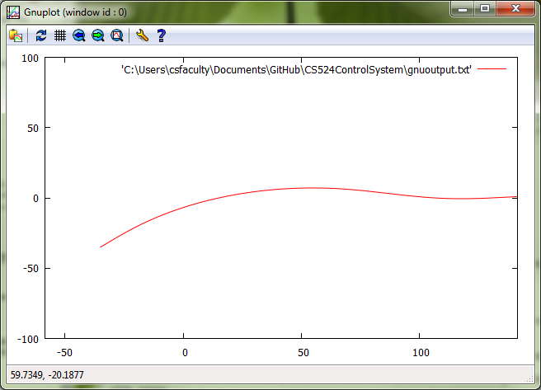

-35, -35, 2, 45, false

Iteration Count: 5000

Distance: 9915.94130006045

Area: 12402.603121316084

Average: 1.2723864711747566

Standard Deviation: 1.5841766413729903

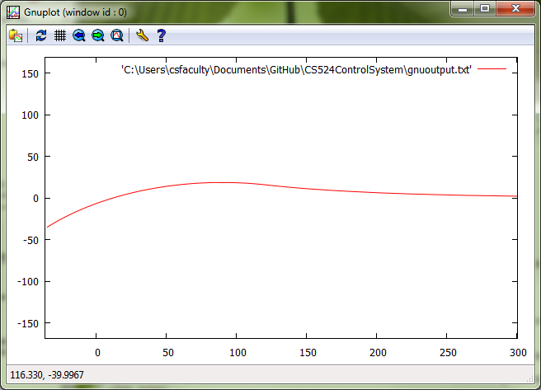

-35, -35, 3, 45, true

Iteration Count: 5000

Distance: 14948.183816248385

Area: 4891.402667489923

Average: 0.3497328185931817

Standard Deviation: 1.948028598959044

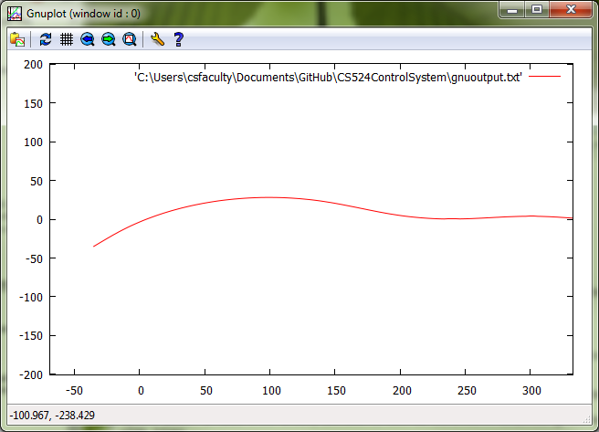

-35, -35, 3, 45, false

Iteration Count: 5000

Distance: 14889.130263145355

Area: 29700.284857727936

Average: 2.0142098519163834

Standard Deviation: 2.6105320838739177